Kol simcha torah gazette
For parshas shemini 5784
Volume 8 Issue 30 (Whole #388) 27 Adar Sheni 5784/ April 6, 2023
Printed L’illuy nishmas Nechama bas R’ Noach, a”h

For a free subscription, please forward your request to keren18@juno.com
Past emails can be found on the website ShabbosStories.com under Brooklyn Torah Gazette

Joseph Lieberman, 82, U.S. Senator, Vice-Presidential Nominee, and Proud Jew

By Eli Rubin and Dovid Margolin
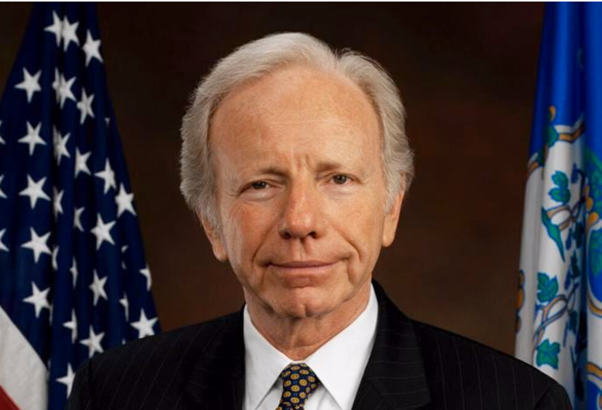

Joseph Isadore (Yosef Yisrael) Lieberman was born on Feb. 24, 1942, and grew up in an observant Jewish home in Stamford, Conn. Photo: Wikimedia

If there is one word with which Joe Lieberman’s name is most associated, it is the Jewish day of rest: Shabbat.
Lieberman, who faithfully observed Shabbat throughout his high-profile political career, passed away on March 27. He served four terms as U.S. senator from Connecticut, and in 2000 was nominated for vice-president on the Democratic Party ticket, becoming the first Jewish candidate to represent a national party platform. In the critical fall weeks before the election, Lieberman let it be known that on Rosh Hashanah, Yom Kippur, Sukkot, and Simchat Torah, he would not be on the campaign trail, but in the synagogue.¹
In 2011, towards the end of his fourth term in the Senate, Lieberman published his seventh book, titled The Gift of Rest: Rediscovering the Beauty of the Sabbath.
Shabbat observance and synagogue attendance were only the most public dimensions of his commitment to Jewish life and practice.

A Strong Relationship with the Lubavitcher Rebbe
Lieberman kept kosher, laid tefillin every weekday morning, prayed three times daily, and regularly studied the weekly Torah portion. He became acquainted with the Lubavitcher Rebbe—Rabbi Menachem M. Schneerson—of righteous memory while still in college and maintained a strong relationship with the Rebbe and with the Chabad-Lubavitch movement for the rest of his life.
Lieberman was first elected to the Senate in 1988, scoring an upset victory over Lowell Weicker. On his way to Washington, D.C., to take the oath of office, Lieberman stopped in Brooklyn, N.Y., to receive a blessing from the Rebbe.
“I saw your picture in the paper,” the Rebbe told him. “May G-d Almighty bless you to be successful in your new position and to be a source of pride for the Jewish people in general.”
“Thank you, Rebbe,” Lieberman replied. “I’m going to try my best … It’s a great opportunity and a great responsibility to do whatever I can to sanctify G-d’s name.”

An Early Stand for Shabbat
Joseph Isadore (Yosef Yisrael) Lieberman was born on Feb. 24, 1942, and grew up in an observant Jewish home in Stamford, Connecticut. His parents, Henry (Chanan) and Marcia (Masha), were both born in the United States to Jewish parents who had emigrated from Poland and Austria in the early 1900s.
When Joe was growing up in the 1940s and `50s, the Liebermans were among the only—perhaps the only—Shabbat-observant young families in Stamford, said Rabbi Yisrael Deren, a longtime family friend who, with his wife Vivi, established Chabad of Stamford in 1988. On Shabbat afternoons in the summer, when most neighborhood children would go down to the beach to swim, Marcia Lieberman would prepare games and refreshments in her home and invite the Jewish kids over so that they, too, could keep Shabbat.
“Maybe she didn’t call it that, but she made a ‘Mesibos Shabbos’ program in her house and made it the place to be on Shabbat afternoon,” said Rabbi Deren. “We were not the first shluchim in Stamford. Joe’s mother was.”

The Prom King Who Missed the Prom
The environment rubbed off on Joe. In his senior year of high school, he was elected prom king, but because the prom was held on Shabbat he chose to forgo the honor and stick to his religious commitments instead.
His maternal grandmother, Minnie (“Maintza” in Yiddish) Manger, was an important presence in young Joe’s early life. She had carried the legacy of traditional Jewish life across the ocean from Europe, and he described her as “the religious foundation of our home.” In Poland, she had been persecuted for her religion, but in America she was respected for her observance. Thus, in addition to being a proud Jew, she became a proud American too.
When she passed away, in 1967, her grandson decided that he would emulate and perpetuate her legacy in his own life. With her very last words, he recalled, she conveyed her love for Shabbat. “If I let go of the link in the chain,” he reasoned, “it would be broken and lost to me and my children after me.”
While speaking of his grandmother in a 2021 interview, Lieberman was reminded of a Yiddish statement by the Sixth Lubavitcher Rebbe—Rabbi Yosef Y. Schneersohn, of righteous memory—“America iz nisht andersh - America is no different.” “Yes,” he reflected, “you can be a Jew here.”²
“He impacted a generation of young American Jews,” said Deren. “Whenever he spoke in schools, to groups, he’d tell them not only is there no contradiction between Torah and mitzvot and public life, but that such commitment was an advantage, something Americans respected you for.”

Yale, and a First Encounter with the Rebbe
In 1960, Lieberman entered Yale University. There he was taken under the wing of New Haven Jewish community activist William Horowitz, who was appointed the first Jewish trustee of Yale in 1965. Horowitz, Lieberman recalled, “was quite fascinated by the Rebbe, and by the Lubavitch movement, generally.”
It was Horowitz who first took Leiberman along for a visit to the Rebbe’s synagogue at 770 Eastern Parkway in the Crown Heights section of Brooklyn. (The second guest, it should be noted, was Yale’s then-chaplain William Sloane Coffin.)
“It was Simchat Torah … we went to 770, and saw not just the normal fervor and excitement … but the special, extra spiritual dimension of Simchat Torah,” Lieberman recalled.
He described this encounter as “a phenomenal experience,” which helped to solidify his own commitment to his Jewish identity. On that occasion, he was one member of a vast crowd. But he would later establish a personal connection with the Rebbe, corresponding with him and interacting with him in person.
Over the course of his storied political career, he traveled across the United States and the world, and developed warm relationships with many Chabad representatives and institutions, in his words in The Gift of Rest, “from Budapest to Beijing, and from Taipei to Tashkent … .”
Of his first face-to-face encounter with the Rebbe, Lieberman said, “of course, his eyes were very compelling, so I remember the moment.” He raised a small glass of wine, and the Rebbe wished him “L'chaim!” (“to life!”).

Came Back to 770 “Over and Over Again”
Lieberman cherished the opportunities he had to visit 770 and listen to the Rebbe teach at his legendary farbrengens, which often lasted many hours. He came back “over and over again,” and found himself “deeply impressed by the spirituality, the extraordinary scholarship of the Rebbe, by the devotion and attentiveness of the Chassidim there, and by their joy.” As the evening got later, Lieberman added, he could only marvel “at the intellectual and physical energy and stamina of the Rebbe, who continued to bring out of himself, essentially, as I could see, without [reference to] a note, the most deeply spiritual and profound insights.”
At a 1995 event held in Washington on the first anniversary of the Rebbe’s passing, Lieberman recalled those farbrengens in 770, holding a small cup of wine in his hand and hoping to catch the Rebbe’s eye for a moment. “That’s what it feels like now,” Lieberman told the crowd. “We all want to do things to catch the Rebbe’s eye.”
At Yale, Lieberman formed another important friendship that would eventually strengthen his bond with Chabad. His roommate was Richard Sugarman, who began his own journey to Jewish observance after accepting an invitation to spend the High Holidays at the Lieberman family home in Stamford. Sugerman—who has been a Professor of Philosophy and Religion at the University of Vermont since the early 1970s—ultimately became a Chabad Chassid and also a close friend of Bernie Sanders, the senior U.S. senator from Vermont.

A Path of Public Service
After earning a law degree and working briefly as a lawyer, Lieberman was elected to the Connecticut Senate in 1970. At this point he received a letter from the Rebbe, which he described as “a brief dissertation” on the exhortation of the prophet Jeremiah (29:7) to “seek the peace of the city” wherein you dwell “for in its peace you shall have peace.” For a young man “beginning a career of public service,” Lieberman later recalled, “it was a very, very, powerful message,” which he came to see as expressing the fundamental ethos of Chabad as a movement. In Lieberman’s words:
“It is a Jewish movement, but it is a movement that gives each of its inheritors a responsibility to carry the underlying principles and ethics, and action, of Torah, out to the world—acts of kindness, acts of justice, and the rule of law.”
After serving three terms as Majority Leader in the Connecticut Senate, Lieberman held the office of Connecticut Attorney General from 1983 to 1989. Following his victorious bid for the U.S. Senate, he brought his entire family, including his elderly mother, to visit the Rebbe in Crown Heights.

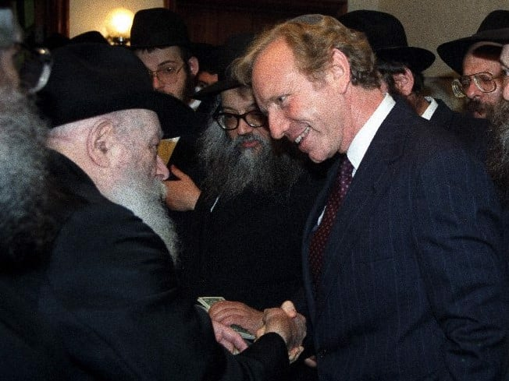
Senator Lieberman getting inspiration from the Lubavitcher Rebbe.

As he later explained, “I went to him right before going to LaGuardia airport to take the shuttle to Washington … That was a Sunday afternoon, he was distributing the dollars for charity, and we spoke for a while, and I have a tape of that, which I cherish and look at very often. I appreciated, not only his blessing as I began this new chapter in life, but also the way he urged me on to make the most of it.” Lieberman was also impressed by the way the Rebbe took the time to speak to each member of his family, “with remarkable relevance,” saying “a little something special” to each one, “from my mother to our then youngest child, who was less than a year old.”
Rabbi Deren, who together with his wife would walk over to Marcia Lieberman’s home to make Havdalah after every Shabbat until her passing in 2005, noted that Joe was a loyal son who would call his mother every single day. She, naturally, was proud of him too.

Proud of Her Son the U.S. Senator’s Connection with the Rebbe
“She’d say, ‘I’m very proud that I raised a son who became a U.S. Senator, but I’m even prouder that that son knew to go to the Rebbe for a blessing before he went to Washington.’ ”
Lieberman stood out in Washington for his religious convictions and for the integrity that was for him part and parcel of these beliefs. The cot he kept in his Senate office in case he’d need to sleep there overnight if a Friday vote went late became legendary. Once, in his early years in D.C., then-Senator Al Gore of Tennessee invited the Shabbat-observant Lieberman to stay over in his father’s comfortable apartment across the street. Gore insisted on accompanying him there so that he could turn on and off lights and make sure Lieberman was comfortable.
Lieberman’s Shabbat observance came onto the national stage in 2000, when by-then Vice President Gore chose him as his running mate. In his Gift of Rest, Lieberman recalls one particularly memorable Shabbat dinner that he and his wife, Hadassah, spent with the Gores during the hotly contested election recount.
“When we were done and it was time to leave, Al asked if we were going to walk home,” Lieberman wrote. “We said yes, and he and Tipper said they would accompany us. We resisted; but they persisted; and so, on that beautiful December night, the four of us—with the Secret Service discreetly walking behind and security cars ahead and behind—walked … to our house” a little more than a mile away.

Teaching the Entire D.C. Establishment about Kosher Food
Kosher food was likewise something the entire D.C. establishment came to learn about. Once, Lieberman and a Jewish congressman found themselves having lunch on Air Force One with President Bill Clinton. The congressman joked that there were now two sandwiches for him because Joe wouldn’t touch his. “What do you mean,” Clinton shot back, “we have special sandwiches for Joe!”
And then there was prayer. In the 1990s, Lieberman recalled in another anecdote shared in The Gift of Rest, he and the late Sen. John McCain were on a plane headed to Bosnia to visit U.S. troops there. As the morning sunlight dawned, Lieberman arose and donned tallit and tefillin to recite morning prayers.
“I noticed John open his eyes for a moment and look at me, then close them again,” Lieberman wrote. “Then, doing a double take, his eyes opened wide.”
“Where am I? What is going on!” the Arizona Republican blurted out.
“Johnny,” Lieberman replied, “I’m just saying my morning prayers,” before briefly explaining what they were.
“Oh good,” McCain cried with relief, “for a moment there, Joey, I thought I’d died and gone to heaven.”
“I remember a Jewish friend of ours owned a department store in a very non-Jewish rural Connecticut town,” said Rabbi Deren. It was election season, and during a casual conversation with his non-Jewish employees, the subject of who they were voting for came up. “Each one said ‘Lieberman.’ When our friend asked them why, they said ‘A man who skips his own nominating convention [on Shabbat] because of his principles is a person we can trust.’ ”

Lessons in Leadership
In 1995, the Rebbe was awarded a Congressional Gold Medal. Lieberman was among the speakers at the celebratory breakfast marking the occasion. “The Rebbe,” he said, “doesn’t need this medal, but America—through its elected representatives—needed to award this medal to the Lubavitcher Rebbe because of what he means to the American Jewish community and to America generally … The Rebbe took the Torah and brought it down to earth for us, and taught us how to incorporate it within ourselves.”
In 2009, Lieberman marked the 15th anniversary of the Rebbe’s passing at a Philadelphia event organized by American Friends of Lubavitch (Chabad). He spoke of how, as a young man, he had found himself “entranced” by “with the fervor, with the spirit, with the sense of purpose” that the Rebbe exuded, and that he was “impressed by his obvious spiritually, by his soaring intellect, by the extent to which he was involved in the world.” The Rebbe, he continued, was “rooted in the Torah, going back to Mt. Sinai,” but was at the same time “involved in the world of today.”
Lieberman noted that the Rebbe displayed great awareness and knowledge of “all the most remarkable technological, psychological, political and medical developments of his lifetime, and spoke to them.” He found the Rebbe, and his emissaries, to be “the most open-minded and accessible of Jewish leaders” providing “the conscience, voice, and guidance for our time.”
In 2013, shortly after concluding his final term in U.S. Senate, Lieberman delivered a keynote address to the International Conference of Chabad Emissaries. On that occasion he spoke of the miraculous salvation of the Rebbe from the Nazis, and of his tremendous achievements as a scholar, teacher, and a leader: “He was a great teacher and a great leader. He was a great theological leader … He built the core of a following, but was constantly reaching out, and pushing his Chassidim to reach out. At the heart of it all was spirituality and a tremendous intellect.”
Lieberman also took the opportunity to “thank all the shluchim … so many of whom have been so good to me as I traveled the country and the world,” together with “their supporters, without whom they could not do the extraordinary work that they do.”
But he singled out a few emissaries in particular with whom he had close relationships that lasted over many years. There was, of course, Rabbi Deren from Stamford, whom he often called his “brother,” as well as Rabbi Avraham Shemtov of Philadelphia, and Rabbi Levi Shemtov of Washington D.C., whom, in an interview with Chabad.org, he referred to as “the Secretaries of State of Chabad.”
“The Rebbe,” he said, “was a leader with a mission to spiritualize the world, to convince people, through acts of kindness and goodness, to bring the world as close as we possibly could, in our time, to perfection—and to do it one by one, mitzvah by mitzvah … until that time when the world is filled with the knowledge of the L-rd.”
Joseph Lieberman’s first marriage to Betty Haas ended in divorce in 1982. He is survived by their children Matthew and Rebecca. He is also survived by his wife, Hadassah; their daughter, Hana; his stepson, Ethan; two sisters; and many grandchildren.

FOOTNOTES
1. Laurie Goodstein, ‘Lieberman Balances Private Faith with Life in the Public Eye,’ The New York Times, Aug. 18, 2000,
2. Max Raskin, ‘Interview with Senator Joe Lieberman,’ Dec. 15, 2021.

******************************************************************
And Moshe said: "This is the thing that G-d has commanded that you do - and the glory of G-d will appear to you." (9:6) Every mitzva in the Torah has a myriad of inner, esoteric meanings, which each Jew understands according to his or her intelligence and level of Torah learning. Even the most learned scholar cannot fully grasp these secrets, for human comprehension and understanding of the infinite is limited and finite.
This is why Moses commanded the Jews - "This is the thing that G-d has commanded" - no matter how much one has studied and no matter how many inner meanings a person has learned, the real reason to do a mitzva is because G-d has so commanded. When your intent in performing a mitzva is solely because G-d wants that particular act to be performed, then "the glory of G-d will appear to you." (Tiferet Shmuel)
Reprinted from this week’s email of R’ Yedidye Hirtenfeld’s whY I Matter parsha sheet for the Young Israel of Midwood in Brooklyn.
Rav Avigdor Miller on
Mechitzos and Mixing
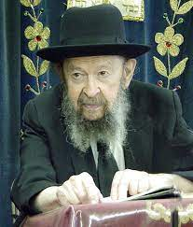

QUESTION: Is there a chiyuv to have a mechitzah at a wedding? I see sometimes Orthodox functions where the men and women are sitting together.
ANSWER: Now, I’m a very little person and that I should give halachic opinions is not my place. But there’s no question that there should be an ideal that men and women should not sit together. It certainly should be an ideal that everybody should strive to fulfill. And if you are the chosson or you are the kallah then you should make up at the very beginning that’s the kind of chasunah you want.
Now why certain functions don’t do that, this is not in my place to say because I don’t know what the circumstances are. I think it’s best to ask the people concerned. But there’s no question that the mixing is a problem. There’s no question about that, my friends, so why should we deceive ourselves.
Mixing men and women is no good; men are wonderful and women are wonderful but when they get together, they both become no good. That’s the plain truth. Even if they’ll get together, men and women, to study Zohar or to study Chovos Halevavos, in mixture it’s no good. No matter what the purpose.
Reprinted from a recent email of Toras Avigdor. Transcribed from Tape #42 (January 1975).
Rabbi Berel Wein on
Parshat Shmini 5784

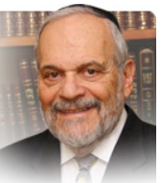

The parsha deals with the eighth day of the dedication of the Mishkan. In general, it can be stated that the eighth day after any event can be a time of challenge. The eighth day of life is the day of circumcision of male Jewish children. The eighth day – the day after the week of rejoicing of a young newly married couple - was and is the day when real married life with all of its joys and challenges begins.

The eighth day after the beginning of the holiday of Pesach in Israel is the day when we return to our ordinary lives and tasks and many times that is a moment of at least temporary depression. And here in the parsha the eighth day is transformed from the day of joy and supreme attainment to one of tragedy and silence.

The eighth day is a difficult day. But the main lesson here is that life is in reality a series of ‘eighth days.’ The eighth day is unpredictable, it can bring pain and sadness but it can also be inspiring and joyful, productive and worthy. So, the eighth day syndrome has become a metaphor for life in general and certainly for Jewish life particularly.

Because of the potential problems and difficulties that the eighth day may bring, the Torah begins the parsha with the word “vayehi” which is not necessarily an expression of happiness. Here it will refer to the untimely deaths of the two sons of Aharon. But in general, it serves as a warning to humans to view life cautiously and realistically. The Torah always teaches us to drive defensively in all areas of living. Aharon’s reaction to the tragedy that has befallen him is noteworthy. The Torah emphasizes that he keep silent. Many times, events occur in human lives that are so shocking, sudden and overwhelming that humans are left speechless. Silence then is really a reflex reaction. But here the Torah records Aharon’s silence as an act of bravery, restraint and holiness and not as a reflex reaction to the destruction of half of his family.

It indicates that Aharon had plenty he could have said and could have taken Heaven to task, so to speak, but instead he himself chose to remain silent. The Talmud in many instances advocates the supremacy of silence over complaint, in fact over unnecessary speech generally. There is much to complain about from our human viewpoint of life and its events. Heaven states that the fact that we are alive and functioning should be sufficient to stifle any complaints.

This hard judgment is also one of the primary lessons of the eighth day. Aharon’s unspoken heartbroken complaint and his unanswered, in fact unasked, question hang in the air of Jewish history – mysterious and unfathomable. This also is true of all eighth day challenges that face us - the righteous and faithful shoulder on.

The great Rebbe of Kotzk said famously: “For the believer there are no questions; for the non-believer there are no answers.” We are all eighth day Jews. Let us also shoulder on to build the Jewish people in strength, compassion and belief.

Reprinted from the current website of rabbiwein.com

The Importance of Loving Ones Fellow Jew

They brought what Moshe commanded before the Tabernacle of Meeting, and all the congregation drew near and stood before G-d (9:5) According to the Kabbalist Rabbi Yitzchak Luria, the commandment to love one's fellow Jew must be accepted before beginning to pray. Only when "the congregation drew near" to each other in love and unity, did the Jewish people "stand before G-d" in prayer and supplication.(Chesed L'Avraham)

Reprinted from this week’s email of R’ Yedidye Hirtenfeld’s whY I Matter parsha sheet for the Young Israel of Midwood in Brooklyn.
What is the Lubavitch Standard for a Shochet?
By Rabbi Hillel Raskin

Rabbi Hillel Raskin

The Alter Rebbe notes that the regular chezkas kashrus that applies to every Yid does not suffice for a shochet; rather, he must be known and recognized as an upright and trustworthy Yid. For this reason, the rov who certifies a shochet and grants him “kabalah” must investigate whether the recipient’s ways are proper and that his fear of Hashem is noticeable.
The shochet must also know how to independently learn Gemara with Rashi, as the Mishna says, “An ignoramus can’t have fear of sin.” The Alter Rebbe adds that even if a shochet possesses kabalah, you should not eat from his shechita unless you personally know the shochet, or he is under the jurisdiction of leaders who are yerei Hashem, so one can be certain that they appointed the correct individual.
If the shechita knife has even a small nick, it is not kosher and can disqualify the shechita. It is easy to miss a small nick unless he truly checks it well. Therefore, those overseeing the kashrus must be certain that the shochtim check their knives properly.
Similarly, the bodek, who checks the animal’s lungs for growths and holes, must be exceptionally yerei Shomayim since it is a careful procedure, and a slight problem can render it a treifa. The signs of a yerei Shomayim vary according to the time and place.
During the Tzemach Tzedek’s era, a shochet was removed due to wearing galoshes, which were a sign of modernity. While a beard and peyos were certainly considered an essential condition, the Frierdiker Rebbe noted that shochtim from certain non-chassidic communities were acceptable even without it.
When a Chabad shochet disgraced a talmid chochom, Reb Hillel Paritcher would not eat from his shechita, and ate from the other shochet instead. In many letters, the Lubavitcher Rebbe highlights that the function of a shochet is not simply to slaughter the animal (skotobyetz, a slaughterer) but to elevate it.
This should, of course, be done by someone with a heightened level of spiritual sensitivity (even more so than a rov) whose way of life reflects being the “heart” of the community. For these reasons, chassidim were particular that the town shochet should be a chossid who lives by the ideals of Chassidus.
In a yechidus with Harav Yitzchok Hendel, Lubavitcher rov of Montreal, the Lubavitcher Rebbe said that while he may eat from and certify any shochet who he knows to be a yerei Shomayim, in order to call a certain shechita “Lubavitcher Shechita,” the shochet must be someone who learns and lives by the ideals of Chassidus Chabad.
In a letter, the Rebbe adds that since a shochet must be exceptionally yerei Shomayim, he must learn Chassidus that brings to yira tata’a and yira ila’a which can only be achieved through avodas hatefilah. 10

Reprinted from the Parshat Tzav 5784 edition of The Weekly Farbrengen. Rabbi
Raskin is Rov of Anash in Petach Tikva, Israel.

Moshe’s Question to His Brother Aaron
Moses told Aaron, "Come close to the altar." (9:7) Rashi states: Aaron was reserved and afraid to come close. Moses said to him, "Why are you reserved? For this you were chosen."
The Baal Shem Tov explains Rashi's comments in the following manner: You were chosen for this - because of your reserve and modesty, and your doubts about being worthy to carry out the Divine service. These are the qualities that demonstrate your being fit for the job. (L'Chayim)
Reprinted from this week’s email of R’ Yedidye Hirtenfeld’s whY I Matter parsha sheet for the Young Israel of Midwood in Brooklyn.

March 31, 2024 was the 432nd Anniversary of Ferdinand and Isabella’s Decision to Expel Jews from Spain who Refused to Convert to Christianity

